

**SCHOOL OF COMPUTING SCIENCE & ENGINEERING**

BCS01T1001

Data Analytics Using Excel and Tableau

LAB MANAUL

SESSION 2020-2021 YEAR – 1ST SEMESTER – 1 (ODD)

SUBMITTED BY – SUBMITTED TO-

***Name* – *Avdhesh Kumar* Dr. Soumyla Ghosh**

**Roll. No. – *20SCSE1010419***

**INBOX**

|  |  |  |  |
| --- | --- | --- | --- |
| **S No.** | **DATE OF SUBMISSION** | **LIST OF EXPERIMENTS** | **Teacher’s**  **Signature** |
| **1.** | **07-12_2020** | **Installing Data Analysis Tool in Excel, Reading and Manipulating**  **data in Excel** |  |
| **2.** | **14-12-2020** | **To Perform Basic Operations and Functions using Excel** |  |
| **3.** | **21-12-2020** | **Working with Formulas and Functions in Excel** |  |
| **4.** | **04-01-2021** | **Working with Filtering Operations, Pivot tables and charts using Excel** |  |
| **5.** | **11-01-2021** | **Working with Histogram and Descriptive Statistics in Excel** |  |
| **6.** | **18-01-2021** | **Working with Moving Average and Exponential Smoothing** |  |
| **7.** | **25-01-2021** | **Working with Correlation and Regression in Excel** |  |
| **8.** | **01-02-2021** | **Installing Tableau Public - Getting Data and visualizing data on maps** |  |
| **9.** | **08-02-2021** | **Advanced Graphing and Charting in Tableau** |  |
| **10.** | **15-02-2021** | **Perform Real Word Data Analysis using Excel and Tableau** |  |

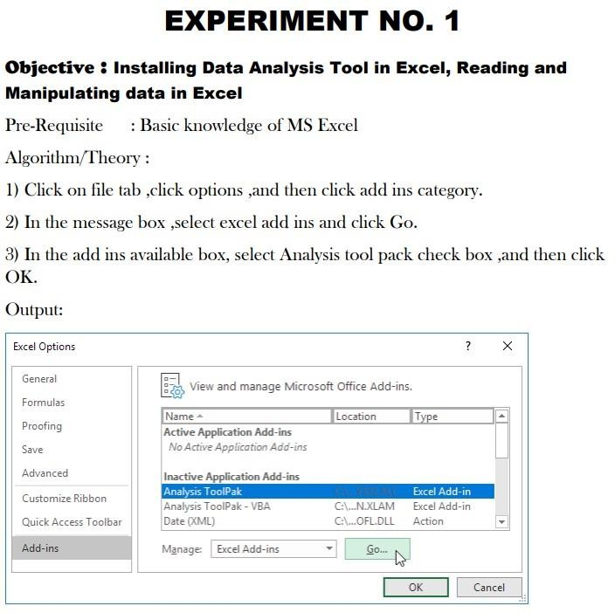

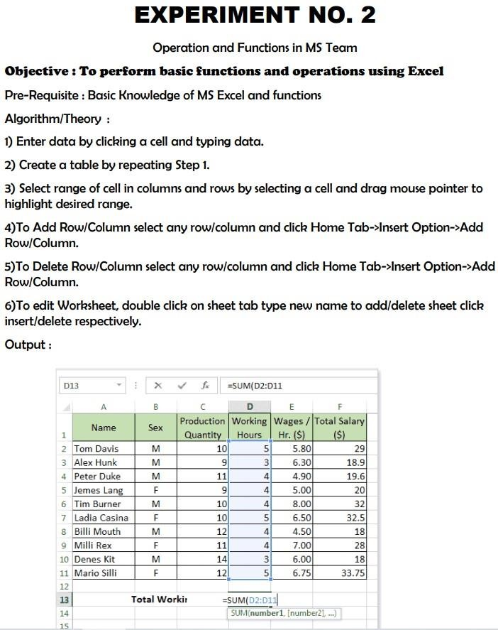

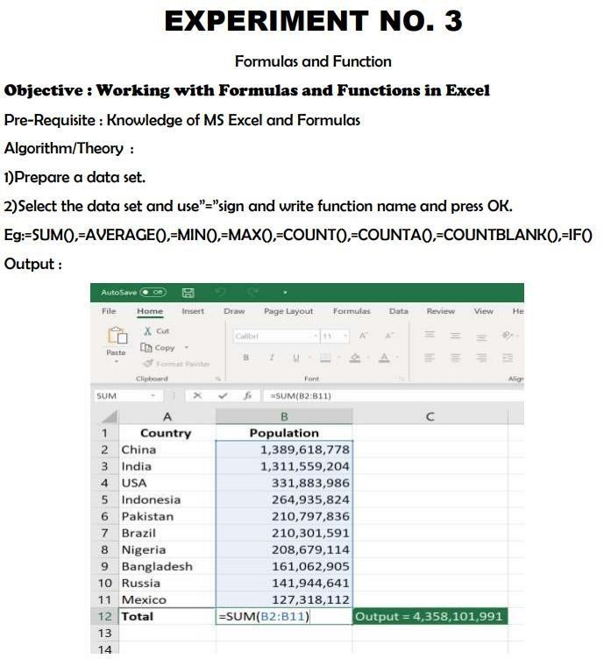

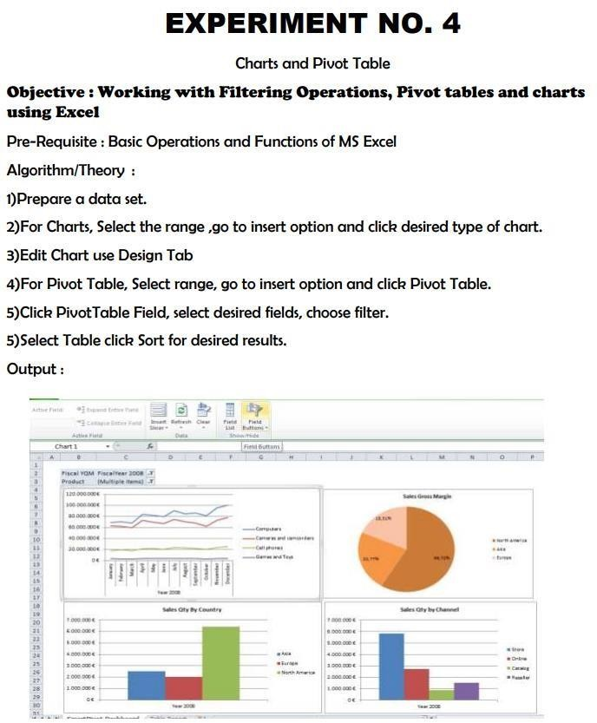

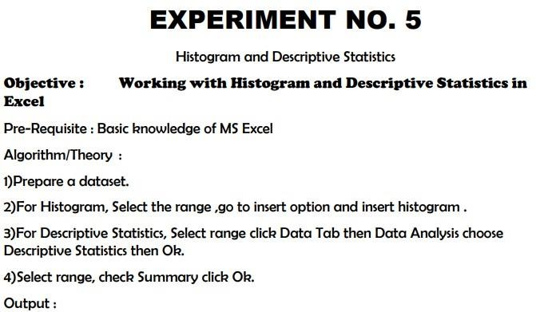

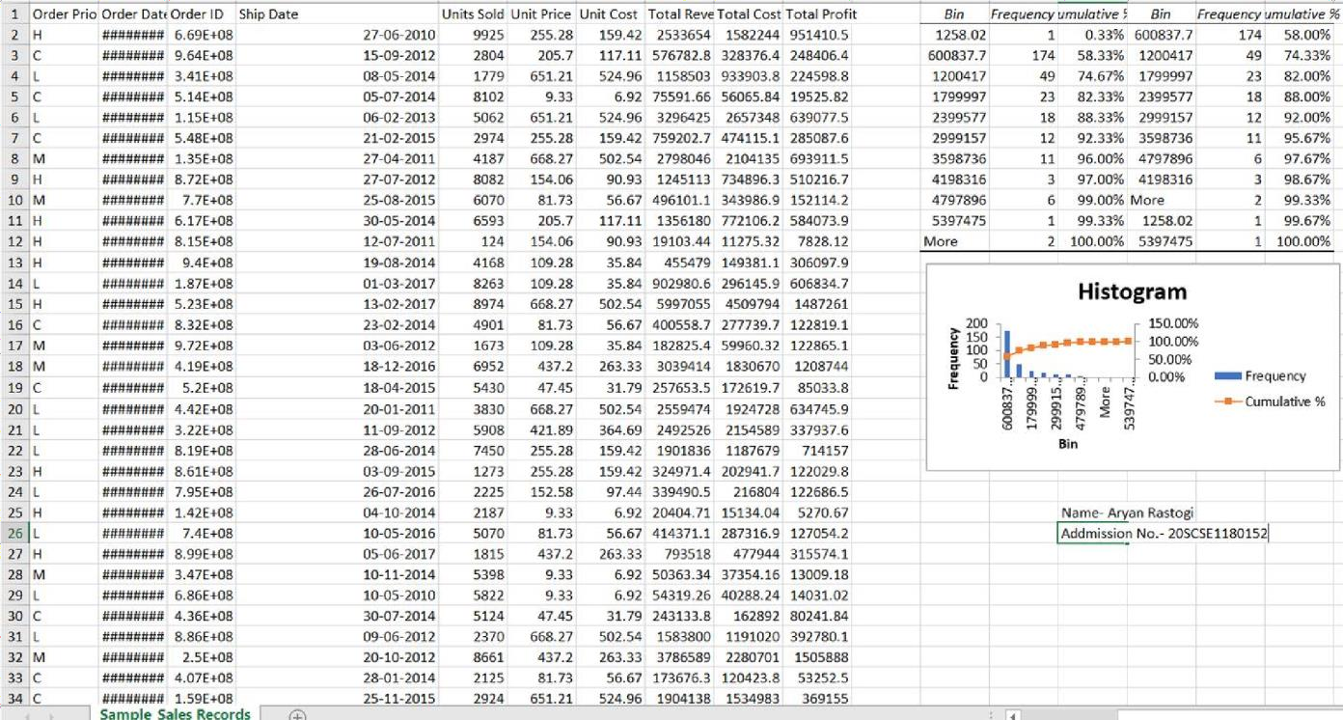

HISTOGRAM

DESCRIPTIVE STATISTICS

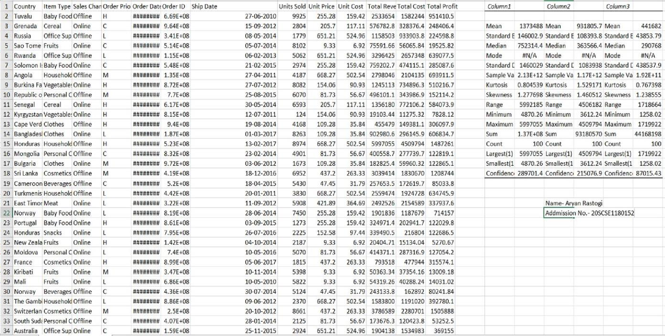

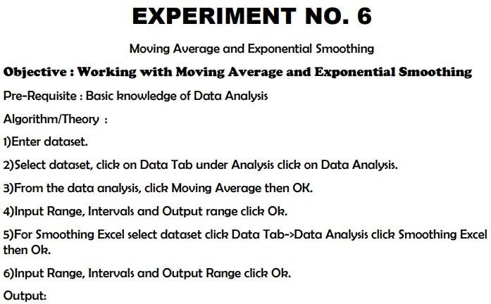

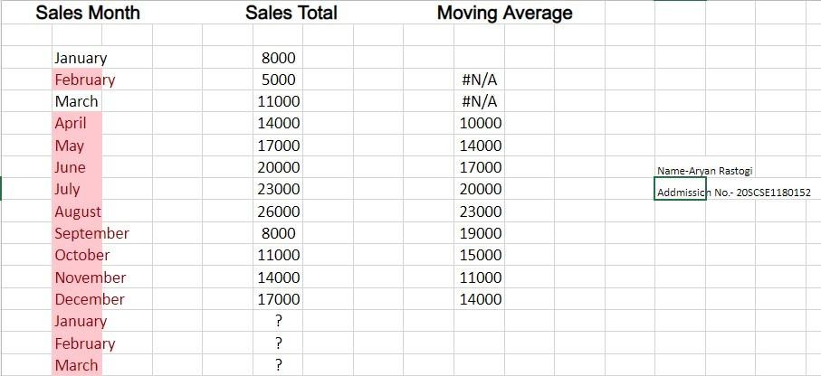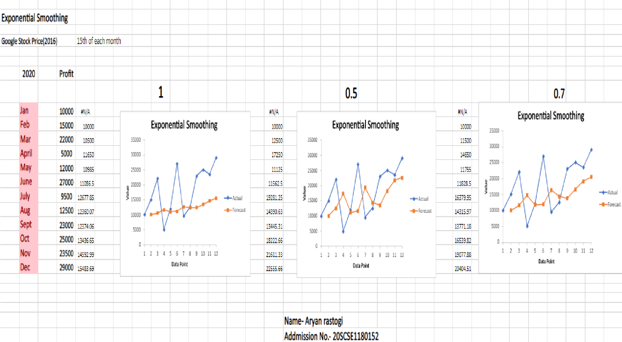

Moving Average EXPONENTIAL SMOOTHING

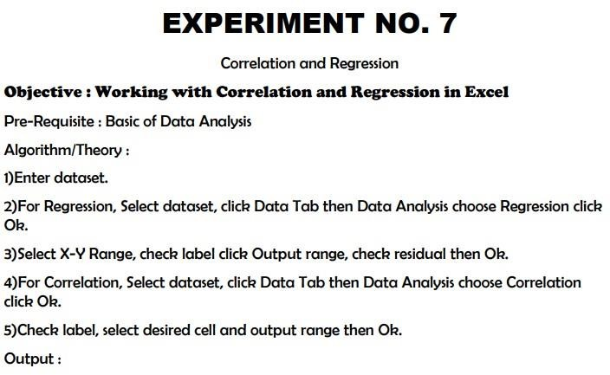

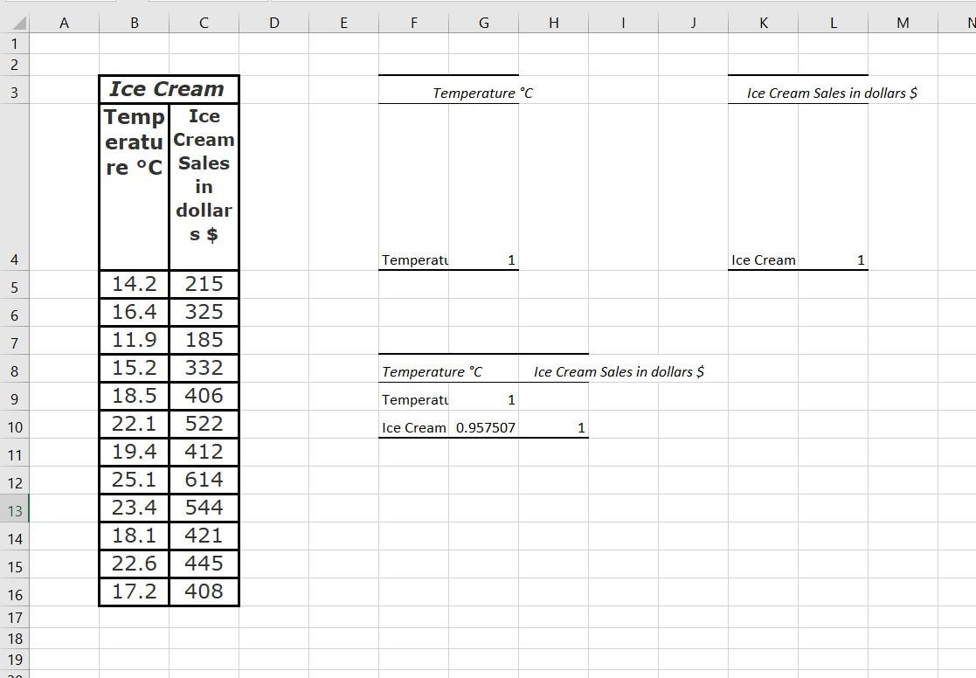

Correlation

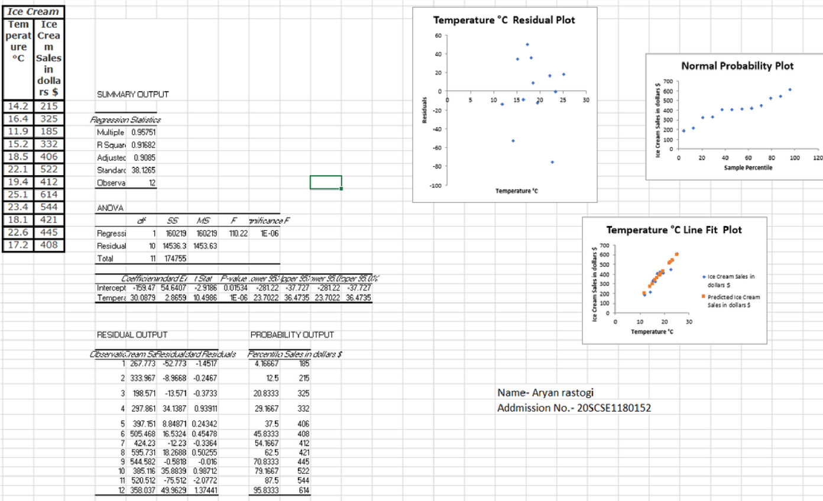

Regression

